DT021-1 Electrical Machine and Power Electronics

POWER ELECTRONICS Lecture 2: Fundamental Switching Concepts

- Duty Cycle, Switching Period, Switching Frequency
Switch is closed for time = t_{on}
Switch is open for time = t_{off}
Switching pattern repeats with period T_{switch}=t_{on}+t_{off}
Switching frequency = f_{switch} = 1/T_{switch}

Duty Cycle (D) = proportion of cycle for which switch is closed:
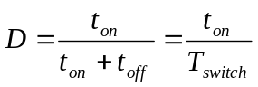

- Ripple / Noise
Switching creates square wave voltage waveforms which are filtered by the circuit L and C. Some underlying ripple remains on the output voltage. The higher the switching frequency the easier it is to filter out and the smaller L and C required.

Ripple: Refers to a low or medium frequency repeating oscillation on the output voltage at the switching frequency f_{switch}. Ripple is usually sinusoidal or triangular and is specified by its root mean square value.
Noise: Refers to high frequency (MHz) spikes superimposed on the output voltage. Noise is caused by ringing of parasitic Ls and Cs in the circuit at every switching instant. Noise is usually specified by its peak to peak value.
time
ripple
noise
V_{out}
- Losses in an ideal switch
The ideal switch has zero impedance when closed and infinite impedance when open and switches between the two states instantaneously. In the closed state losses are zero because voltage drop is zero. In the off state losses are zero because the current is zero. The ideal switch has zero losses.

- Losses in a real switch switching a resistive circuit

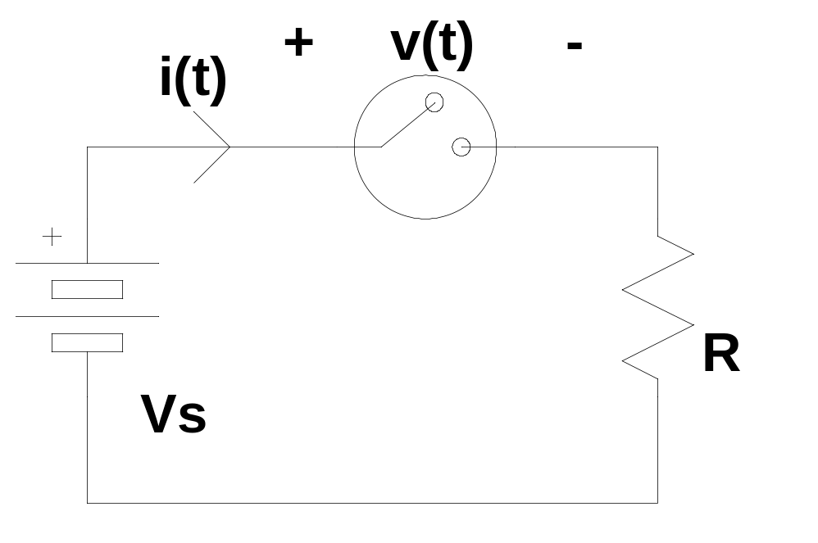
I_{on}
V_{s}
V_{on}
time
t_{rise}
t_{fall}
i(t)

v(t)
At any instant of time the losses in the switch can be said to be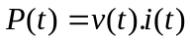

In practise the average loss over time can be broken down into three components:
- Conduction losses – arising from the non zero voltage drop during the on-state
- Switching losses – arising from the finite switching speed from one state to another
- Additional losses would arise if there were a small leakage current during the off state. This type of loss is almost always negligible.

Conduction loss calculation:
Assuming that the rise and fall times of the current are much less than t_{on}

Conduction loss = P_{cl} = V_{on}.I_{on}.D
Switching loss calculation:
Assume that current i(t )rises linearly during t_{rise} and falls linearly during t_{fall}
This means that v(t) = V_{s}-i(t).R must fall and rise linearly during these respective periods.

The energy lost in the switch during the rise time of the current = 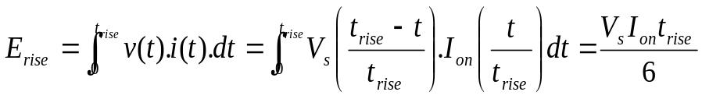
Similarly the energy lost in the switch during the fall time of the current = 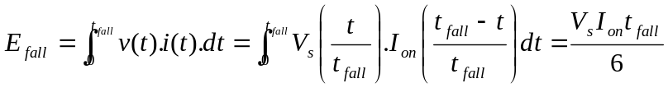

Since each of these losses occurs once during a switching cycle the average power lost due to switching is:
Switching loss = 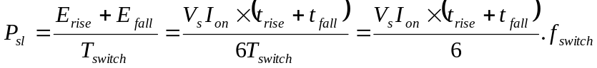

Notice: Conduction losses depend on duty cycle but are independent of switching frequency. Switching losses are independent of duty cycle but depend on switching frequency.

Design Trade-off: A high switching frequency is desirable in order to minimise ripple and allow the use of smaller L and C in the filter. However a high switching frequency causes increased switching losses.
5. Losses in a real switch switching an inductive circuit
In an inductive circuit the circuit inductance will attempt to keep current flowing while the switch is opening. Inductive circuits must have some form of alternative path (usually a freewheel diode) to allow the inductor current to continue to flow after the switch has opened otherwise very large induced voltages (v=Ldi/dt) would damage the switch.
Example:
Step down DC/DC switching converter (Buck Converter)

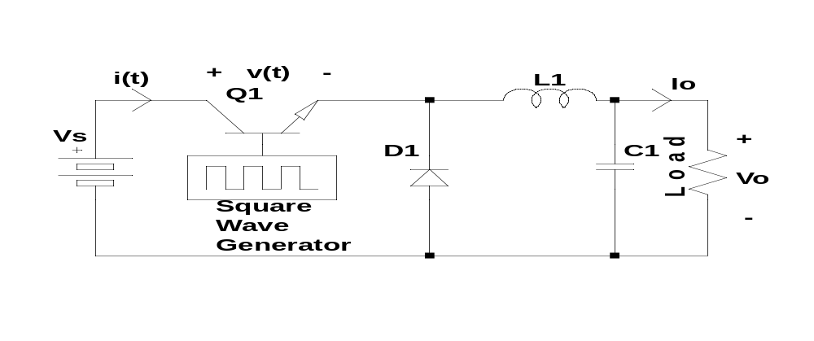
Assume that the inductor L1 is sufficiently large that the current flowing in it does not vary through the switching cycle and has very little ripple. Since C1 cannot carry a DC current then the current in L1 is equal to I_{o} the DC output current. As explained in lecture 1 the opening and closing of the switch creates a square wave voltage across the diode. The output voltage V_{o} is the filtered average of this square wave.

Useful Formula for step down converter: 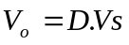

Switch Waveforms:
I_{on}
V_{s}
V_{on}
time
t_{rise}
t_{fall}
i(t)

V(t)
Explanation: When the switch is open the inductor current must flow through the diode. Therefore the diode is conducting and the emitter of Q1 is pulled down to one diode drop above ground. If we assume that the diode drop is small enough to be negligible then the switch sees the full supply voltage V_{s} while it is turned off.

When the switch turns on it starts to take some of the inductor current. However until the switch is carrying the full inductor current the diode must supply the balance. Thus the diode remains conducting for the whole of the rise time t_{rise} and the switch continues to see the full supply voltage for the whole of the rise time.

On the turn off of the switch – as soon as the switch current starts to fall the diode must begin conducting in order to carry the balance of the inductor current. Therefore the switch voltage rises abruptly to the full value of V_{s} the moment the switch turns off.

Contrast this situation with the resistive circuit where the voltage rises and falls in proportion to the current.

Conduction losses
Are unchanged from resistive circuit P_{cl}=V_{on}.I_{on.}.D
In the step down converter I_{on} = I_{o}the output current.

Switching losses:

The energy lost in the switch during the rise time of the current = 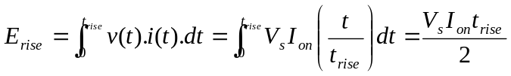
Similarly the energy lost in the switch during the fall time of the current = 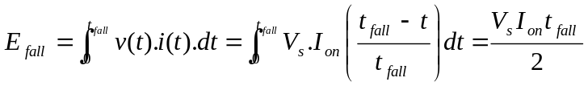

Since each of these losses occurs once during a switching cycle the average power lost due to switching is:
Switching loss = 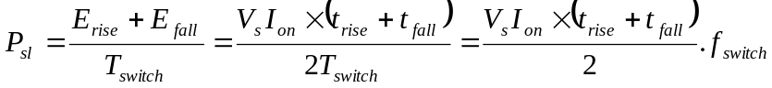
Sample Problem:
- A switch mode step down dc/dc converter produces a 20V, 10Amp output from a 48V input. The converter uses a MOSFET switch operating at 100kHz. The rise time of the switch current is 100ns and the fall time is also 100ns. The MOSFET has an on state resistance of 0.1 OHM. The inductor has a series resistance of 0.05 Ohm and the diode has a forward voltage drop of 0.7V at 10A. The capacitor may be considered ideal.
  - Estimate the Switch conduction losses and switching losses _{(4.17W, 4.8W)}
  - Estimate the inductor losses and the diode losses _{(5W, 4.08W)}
  - Estimate the efficiency of the converter _{(0.92)}

